V1.9 Objectives : diffusion, radius calibration, white noise, exact solution-convergence
V1.90 – 10/07 – Diffusion term C
- Implementation of Diffusion methods, modification of Dt computation to satisfy stability conditions
>Advection OK and time step OK, fix boundary problem
- 2400 is too big to plot
> Bug spotted, the root diameter changes with discretisation ! I just forgot to change the attractant size to root instead of Upward
- Correction of advection velocity: it was taken as 1 in the flux computation
- Estimation impact diffusion in A = 0.03, C = 0.01: large diffusion and disparition of groups
C = 0.005: extremal groups visible. The diffusion works absolutely like a low CFL simulation.
- Without diffusion, radius of E
R0.5e0.5 very thin groups
R2e1 very spaced thin groups
R2e0.1 group formation visible, but weak strength
(Difficult evaluation from homogeneous start. Implementation of sparse initial data ?)
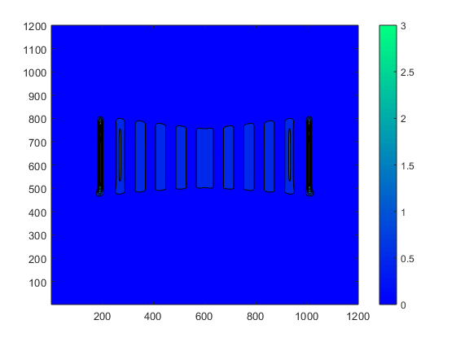
Good parameters balance. However they’re free dimension. + Unstability arised in down corners.
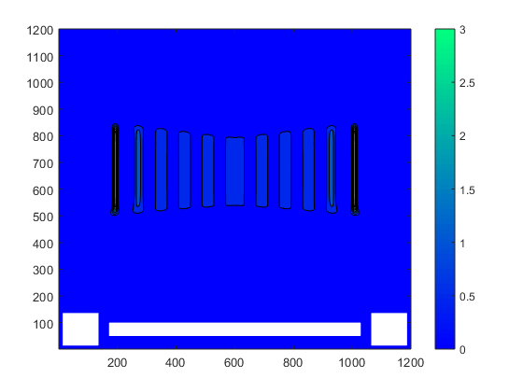
Next: Check vector field + deviation computation
Convergence protocol
- Time save fit: no. First tentative of fitting was unsure (-2 in nSaveVec) and if the recorded time was good, convergence was catastrophic (-0.3)
- Boundary fit: yes
- Initial data fit: yes
11/07 – Convergence study
- Problem of the estimation of the dt in standstill state ! a = 0, so Dt can be infinite.
- Crazy moment: the convergence seems to happen after a certain treshold, and even with an increase of the error !
> Make from the script a function depending solely on Dx, and run simulations
> The convergence computed with the script is a strange decreasing number
- I suspect the formula of “rate of convergence” unreliable. With a loglog plot, I manage to optain a linear curve (> order 1). I will opt to for the log2(uh-ubar/uh2-ubar) solution (the log2 is very important)
> However the computed order is 0.5
12/07 – Convergence study 2 (multi method)
- Lax Wendroff is implemented with an estimated order of 0.6
> What is wrong in my code ? Wy can’t I have a order of 1
- Test forking: R2e0.5 w n3200
Heavy data and figures
Unstability ? Nan generation in the borders
Is the artificial viscosity stronger than the nonlocal deflexion ?
- The sources of NaN are located on the vector field discontinuity. Plus there is still a bug in the generation of the vectorfield
15/07 – Quiver debug
- Fix implemented regarding the generation of vector field. (The attractant was overwritten by PhiBd)
- Reload of 3200 test, T250 to check NaN apparition at n4
- Catch-up objectives (achieved): Diffusion bacteria (implemented, low impact), Radius calibration (R2e0.5, thin films because of unbounded bacteria concentration in advection. Diffusion must be finally required.), convergence (with exact solution on standstill o0.5/0.65 with o1/2 methods. A mistake remains somewhere)
- The NaN source starts at n358, on the right side at the middle of the wall. Direction corrected (dependent on btemp instead of b). Reload of simulation
- NaN starts at 357, and the direction fix had no impact (NaN results from step 356). Reload with 6 different returns and will save the state of btemp and b
26/07 – Quiver Debug 2
- VxNan computation corrupted. Why ? Is the vector field normalised ? Yes
> A strip inside the boundary has been detected. Possible source of NaN.
> A rectangular region in the lower part of the domain allows definition of data in boundaries, including columns and walls
- SU correct, variation between 1 and 1.12
- Ix correct, but clear definition of the rectangular area
Similar for Iy
- Ix, Iy * PhiDef after computation: Vx is still Nan (a return was forgotten preventing the conversion of NaN in 0) Vx ok
> Verification Run:

